Predelava in spravilo sadja

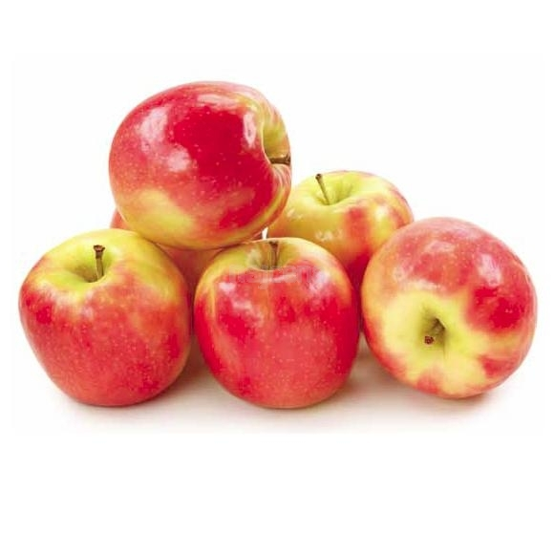

Vinko Medved

2.ČM

Spravilo

Včasih so spravili sadje v ledenice, to so bile kleti katere so obložili z ledom ki so ga nažagali na ribnikih ter ga z vozovmi pripeljali do kleti.

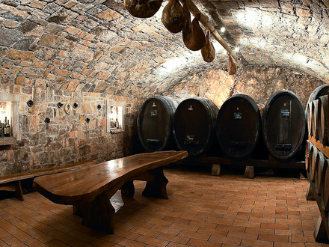

**(slika ni simbolična)**

Danes spravljajo sadjarji svoje pridelke v hladilnice ki imajo večjo kapaciteto in obdržijo jabolka tako da kvaliteta ne pade.

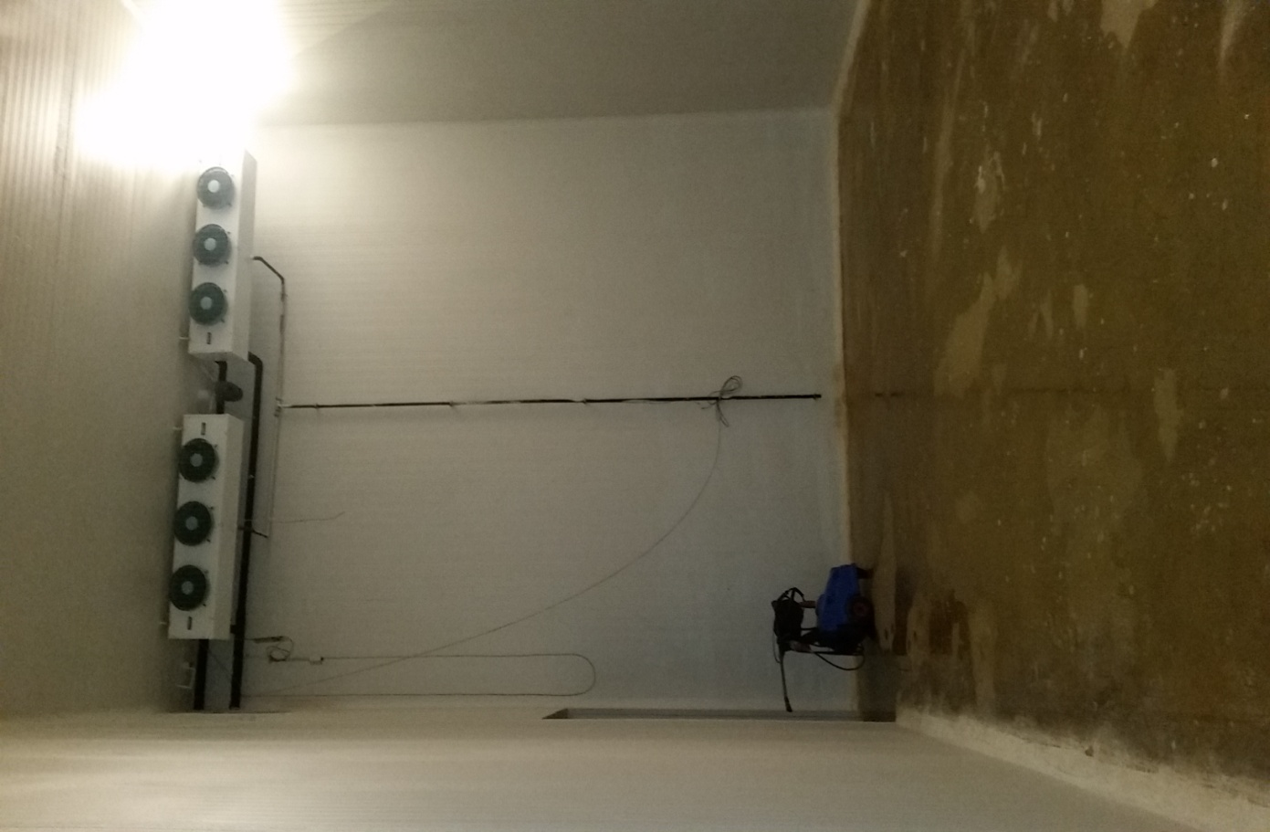

Predelava

Prvo so jabolka dali v mlin in jih zmleli

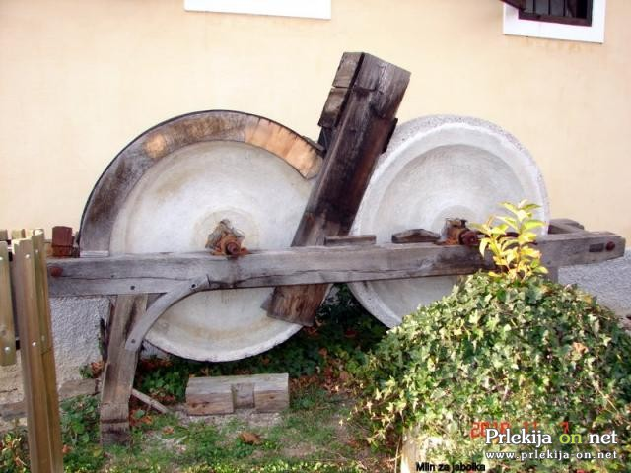

Nato so jih sprešali v stari preši

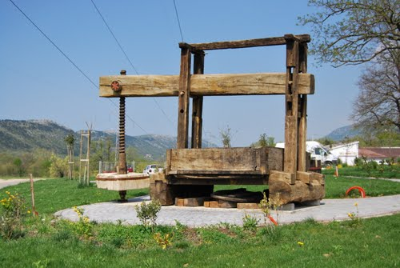

Danes imamo mline na elekto pogon kateri lahko zmeljejo ogromno več jabolk kot pa stari saj so jih poganjali ljudje.

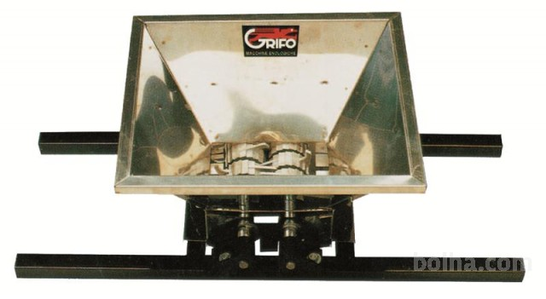

To postavijo nad prešo in stisnejo jabolka. Te sodobne preše imajo večji iskoristek saj z večjo silo stisnejo jabolka in tako dobijo tudi več soka, ter so hitrejše.

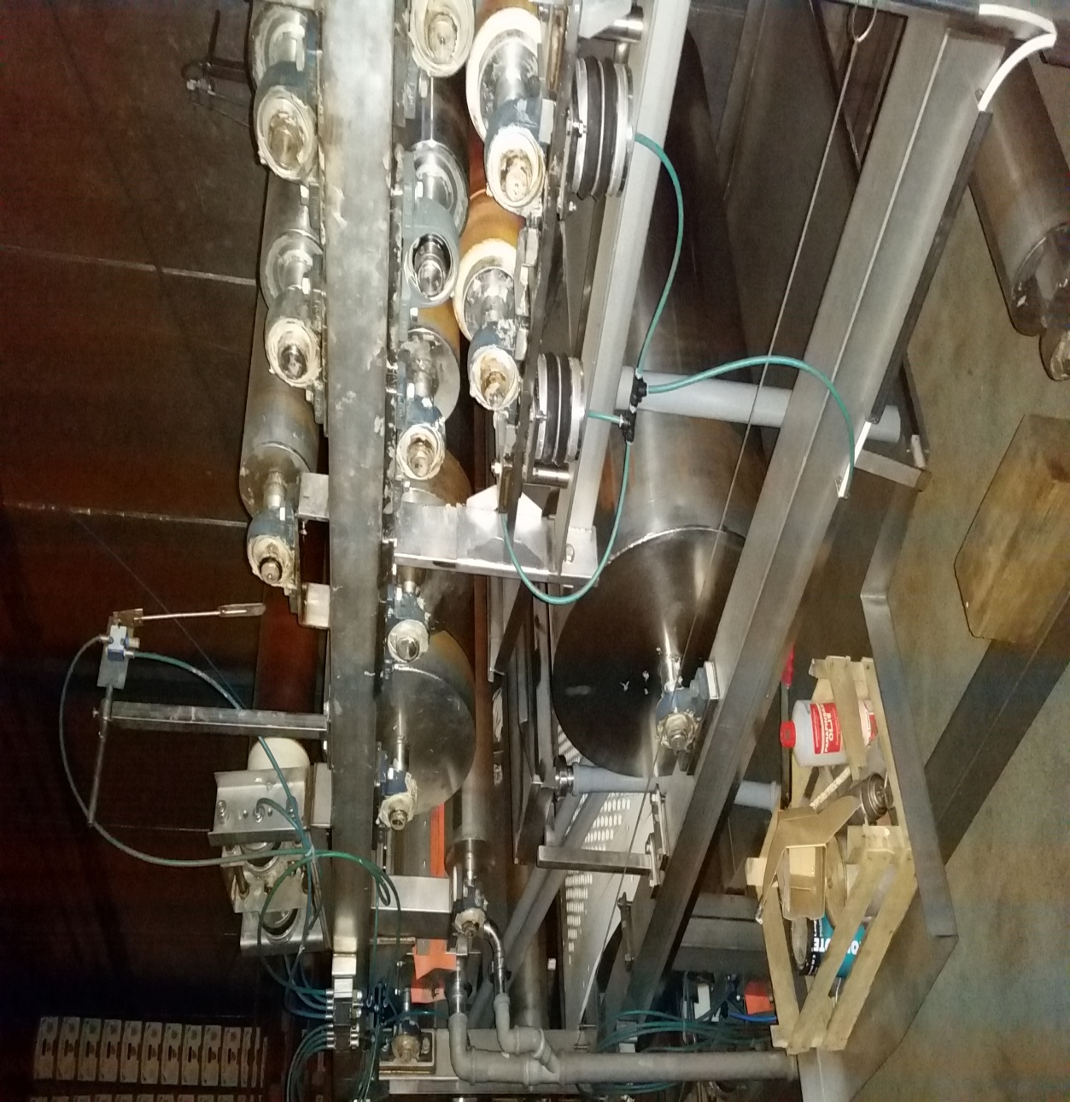

Viri:

1 slika : [https://www.google.si/search?q=doma%C4%8Da+klet&biw=1680&bih=939&source=lnms&tbm=isch&sa=X&ei=TxsmVdLjGcavU_eqgdAM&ved=0CAYQ_AUoAQ#imgrc=JnyygcDAnQ7IMM%253A%3BITqe2Fg7G8n9EM%3Bhttp%253A%252F%252Fwww.sloveniaholidays.com%252Fimg%252Fgallery%252Fvinska-klet-stoka-dutovlje-50871_clientHome.jpg%3Bhttp%253A%252F%252Fwww.sloveniaholidays.com%252Fvinska-klet-stoka-dutovlje.html%3B440%3B330](https://www.google.si/search?q=domača+klet&biw=1680&bih=939&source=lnms&tbm=isch&sa=X&ei=TxsmVdLjGcavU_eqgdAM&ved=0CAYQ_AUoAQ%23imgrc=JnyygcDAnQ7IMM%253A%3BITqe2Fg7G8n9EM%3Bhttp%253A%252F%252Fwww.sloveniaholidays.com%252Fimg%252Fgallery%252Fvinska-klet-stoka-dutovlje-50871_clientHome.jpg%3Bhttp%253A%252F%252Fwww.sloveniaholidays.com%252Fvinska-klet-stoka-dutovlje.html%3B440%3B330)

2 slika : doma

3 slika : [https://www.google.si/search?q=doma%C4%8Da+klet&biw=1680&bih=939&source=lnms&tbm=isch&sa=X&ei=TxsmVdLjGcavU_eqgdAM&ved=0CAYQ_AUoAQ#tbm=isch&q=mlin+za+jabolka&imgrc=HRh9wuXNVmfScM%253A%3BwYBwnyvMPT6m7M%3Bhttp%253A%252F%252Fwww.silvo.si%252Fmedia%252FSlikeIT%252FMlin_za_sadje-1.jpg%3Bhttp%253A%252F%252Fwww.silvo.si%252Fdefault.asp%253Fmid%253Dsl%2526pid%253Dmodul_it%2526wid%253D2902%2526detailID%253D9240%3B800%3B600](https://www.google.si/search?q=domača+klet&biw=1680&bih=939&source=lnms&tbm=isch&sa=X&ei=TxsmVdLjGcavU_eqgdAM&ved=0CAYQ_AUoAQ%23tbm=isch&q=mlin+za+jabolka&imgrc=HRh9wuXNVmfScM%253A%3BwYBwnyvMPT6m7M%3Bhttp%253A%252F%252Fwww.silvo.si%252Fmedia%252FSlikeIT%252FMlin_za_sadje-1.jpg%3Bhttp%253A%252F%252Fwww.silvo.si%252Fdefault.asp%253Fmid%253Dsl%2526pid%253Dmodul_it%2526wid%253D2902%2526detailID%253D9240%3B800%3B600)

4 slika : [https://www.google.si/search?q=doma%C4%8Da+klet&biw=1680&bih=939&source=lnms&tbm=isch&sa=X&ei=TxsmVdLjGcavU_eqgdAM&ved=0CAYQ_AUoAQ#tbm=isch&q=mlin+za+jabolka&imgrc=fRbBW1kF5Q8BRM%253A%3BuSx8dJS-_YatYM%3Bhttp%253A%252F%252Fmmc.bolha.com%252F1%252Fimage%252F175494%252F177234%252FMLIN-ZA-SADJE_53da66f28e66e.jpg%3Bhttp%253A%252F%252Fwww.bolha.com%252Fkmetijstvo-gozdarstvo%252Fvinogradnistvo%252Fmlini-za-sadje%252Fmlin-za-sadje-na-zalogi--1294370102.html%3B640%3B351](https://www.google.si/search?q=domača+klet&biw=1680&bih=939&source=lnms&tbm=isch&sa=X&ei=TxsmVdLjGcavU_eqgdAM&ved=0CAYQ_AUoAQ%23tbm=isch&q=mlin+za+jabolka&imgrc=fRbBW1kF5Q8BRM%253A%3BuSx8dJS-_YatYM%3Bhttp%253A%252F%252Fmmc.bolha.com%252F1%252Fimage%252F175494%252F177234%252FMLIN-ZA-SADJE_53da66f28e66e.jpg%3Bhttp%253A%252F%252Fwww.bolha.com%252Fkmetijstvo-gozdarstvo%252Fvinogradnistvo%252Fmlini-za-sadje%252Fmlin-za-sadje-na-zalogi--1294370102.html%3B640%3B351)

5 slika : doma