**T- FLIP FLOPI (sinhroni in prožen na fronto)**

**Raziskal: Slavko Murko 16.10.2017**

[**http://ranger.uta.edu/~carroll/cse2341/fall98/chapter6/sld039.htm**](http://ranger.uta.edu/~carroll/cse2341/fall98/chapter6/sld039.htm)

**JK Flip – flop to T Flip – flop**

Converting the JK flip – flop to T flip flop, involves in connecting the Toggle input (T) directly to the J and K inputs. So toggle (T) will be the external input to the combinational circuit. Its output is connected to the Input of actual flip – flop (JK flip – flop).

[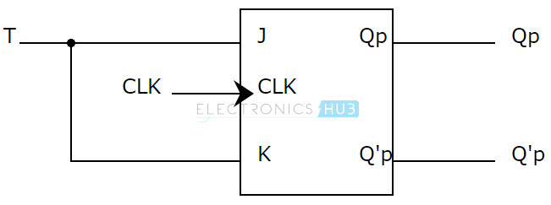](http://www.electronicshub.org/wp-content/uploads/2015/06/JK-TO-T.jpg)

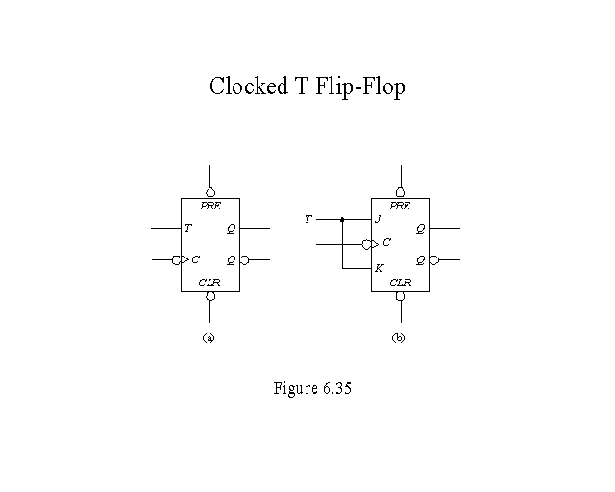

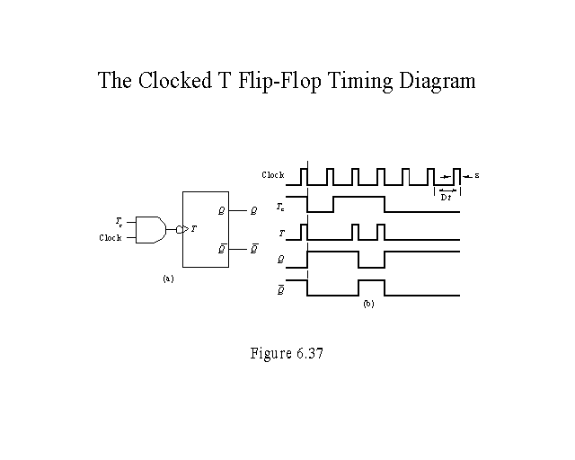

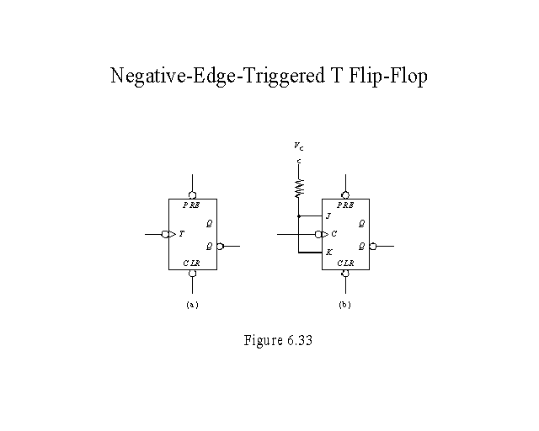

TOGGLE FLIP-FLOP

The toggle, or T, flip-flop is a bistable device that changes state on command from a common input terminal.

The standard symbol for a T FF is illustrated in figure 3-15, view A. The T input may be preceded by an inverter. An inverter indicates a FF will toggle on a HIGH-to-LOW transition of the input pulse. The absence of an [inverter](http://electriciantraining.tpub.com/14185/css/The-Inverter-94.htm) indicates the FF will toggle on a LOW-to-HIGH transition of the pulse.

Figure 3-15. - Toggle (T) flip-flop: A. Standard symbol; B. Timing diagram.

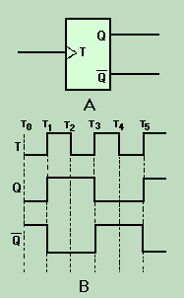

The timing diagram in figure 3-15, view B, shows the toggle input and the resulting outputs. We will assume an initial condition (T0) of Q being LOW and  Q being HIGH. At T1, the toggle changes from a LOW to a HIGH and the device changes state; Q goes HIGH and  Q goes LOW. The outputs remain the same at T2since the device is switched only by a LOW-to-HIGH transition. At T3, when the toggle goes HIGH, Q goes LOW and  Q goes HIGH; they remain that way until T5.

Between T1 and T5, two complete cycles of T occur. During the same time period, only one cycle is observed for Q or Q. Since the output cycle is one-half the input cycle, this device can be used to divide the input by 2. The most commonly used T FFs are J-K FFs wired to perform a toggle function. This use will be demonstrated later in this section.

Q.22 How many inputs does a T FF have?   
Q.23 What is the purpose of using T FFs?

.